# ***8 Programs and their expected outputs***

## Program 1:

#include <iostream>

using namespace std;

int main() {

int a,b;

char operation;

cout << "Enter the first number: ";

cin >> a;

cout << "Enter the second number: ";

cin >> b;

cout << "Enter the operation: ";

cin >> operation;

switch (operation){

case '+':

cout << "The Sum of two values are: "<<a+b;

break;

case '-':

cout << "The Difference of two number are: "<<a-b;

break;

case '*':

cout << "The Product of two numbers are: "<<a*b;

break;

case '/':

cout << "The Division of two number are: "<<a/b;

break;

}

}

## Output:

## Program 2:

#include <iostream>

using namespace std;

int main() {

int factof,factorial;

factorial = 1;

cout << "Enter the number you want factorial of: ";

cin >> factof;

cout << endl;

if(factof < 0){

cout << "You Entered Negative Number So Invalid!";

}

if(factof == 1 || factof == 0 ){

cout << "Factorial of " << factof << " is 1.";

return 0;

}

for(int i=1;i<=factof;i++){

factorial *= i;

}

cout << "The factorial of " << factof << " is " << factorial;

}

## Output:

## 

## Program 3:

#include <iostream>

using namespace std;

int main () {

char gender;

cout << "Enter the gender: ";

cin >> gender;

switch (gender) {

case 'M':

cout << "Gender is Male!";

break;

case 'F':

cout << "Gender is Female";

break;

default:

cout << "Invalid!";

break;

}

}

## Output:

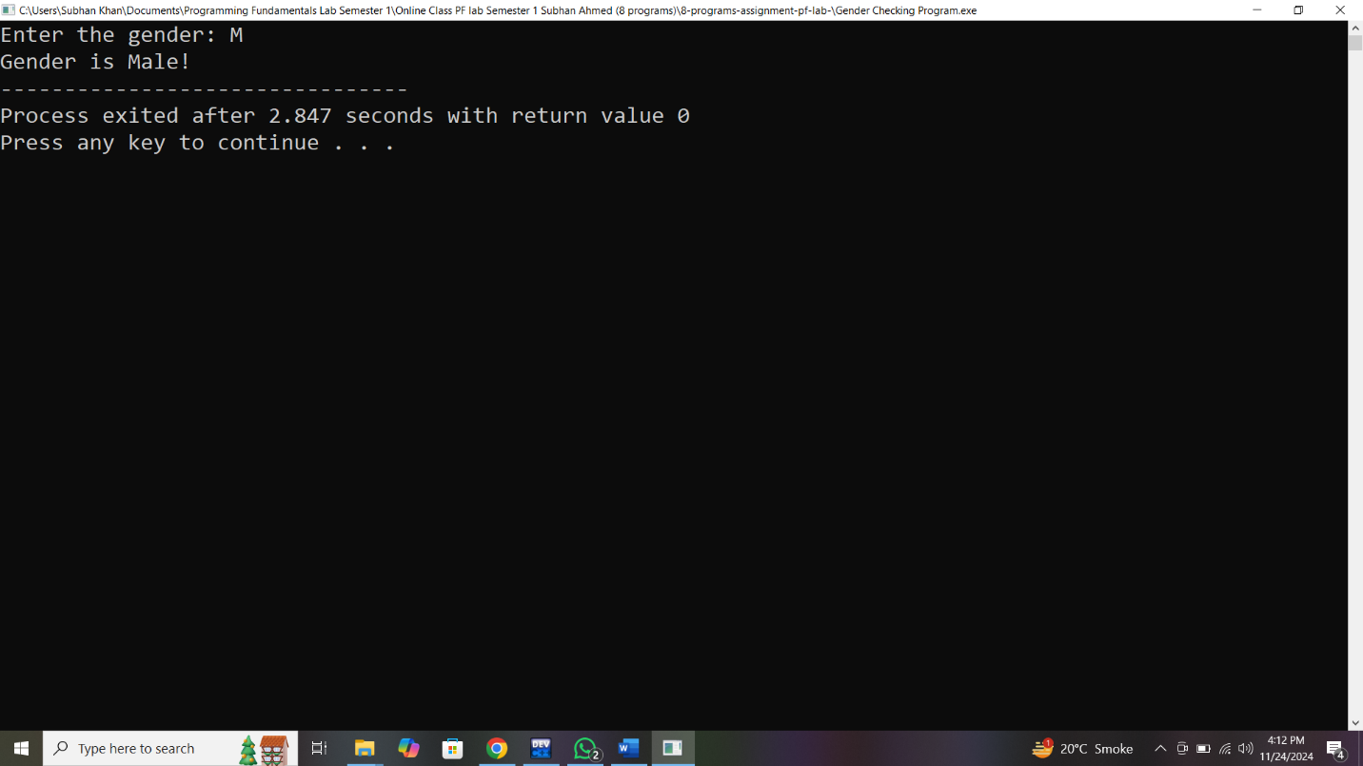

## Program 4:

#include <iostream>

using namespace std;

int main(){

int n1,n2,n3;

cout << "Enter First Number: ";

cin >> n1;

cout << "\nEnter Second Number: ";

cin >> n2;

cout << "\nEnter third Number: ";

cin >> n3;

cout << endl;

if(n1 > n2){

if(n1 > n3){

cout << n1 << " is largest!";

}

}else{

if(n2 > n3){

cout << n2 <<" is largest!";

}else{

cout << n3 << " is largest!";

}

}

}

## Output:

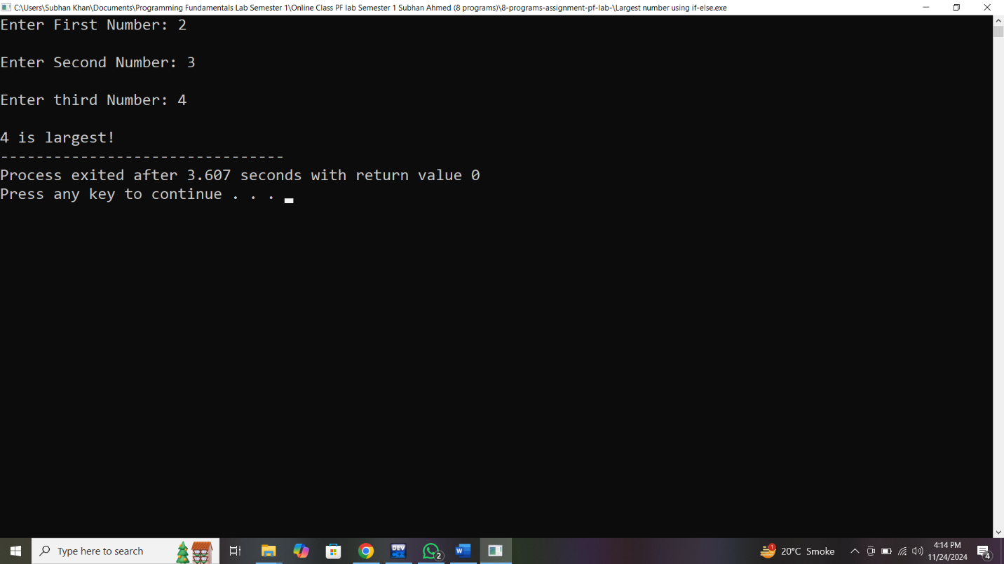

## Program 5:

#include <iostream>

using namespace std;

int main() {

int num;

cout << "Enter the number which you want table of: ";

cin >> num;

cout << endl;

for(int i=1;i<=10;i++){

cout << num << " * "<<i<< " = "<<num*i<<endl;

}

}

## Output:

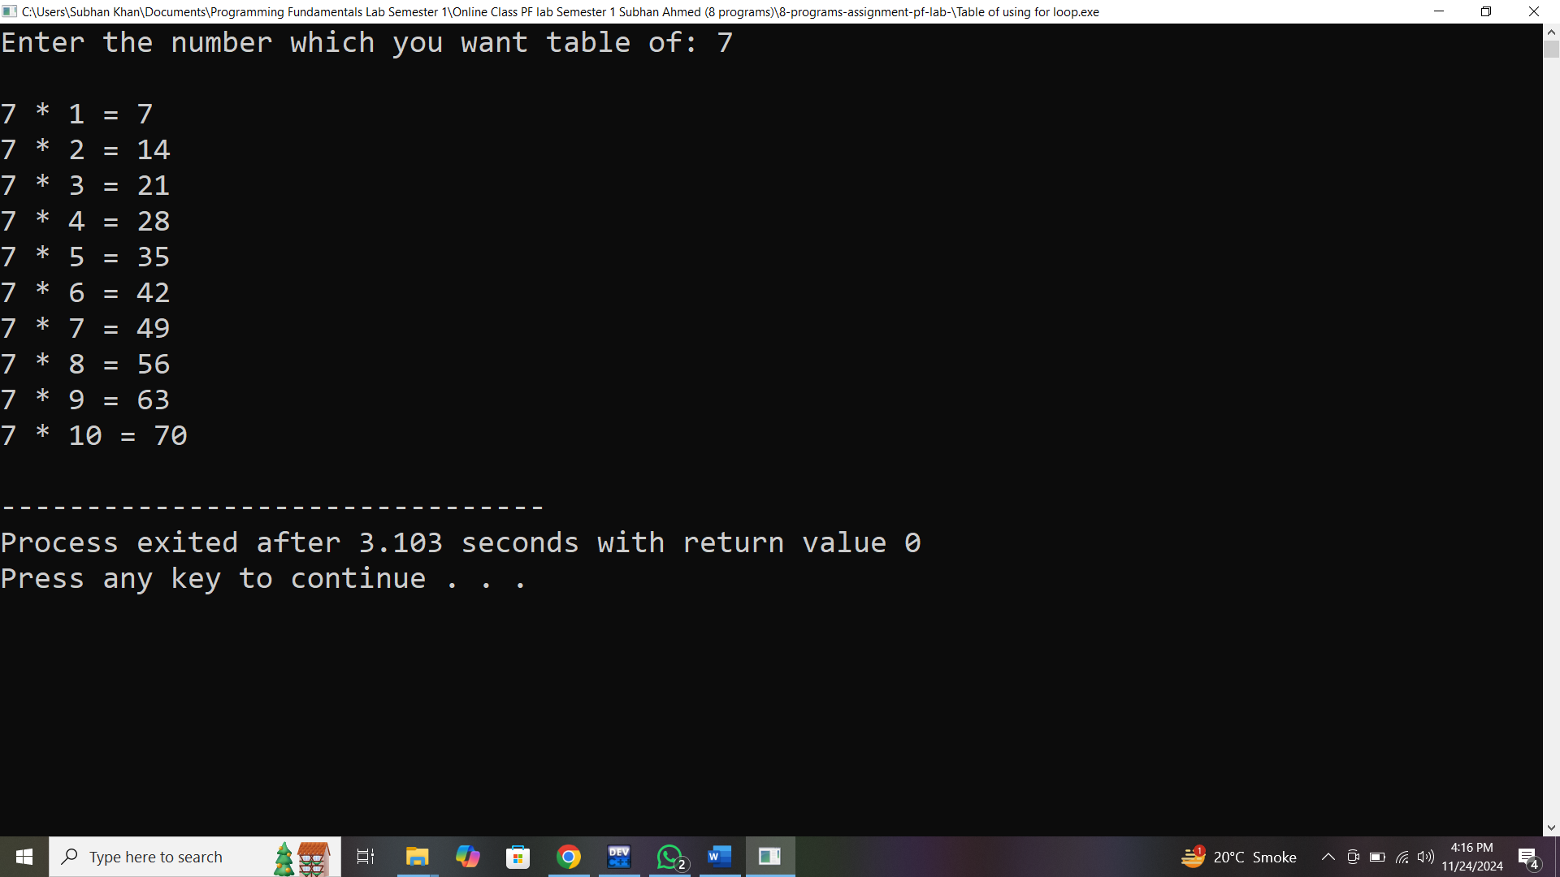

## Program 6:

#include <iostream>

using namespace std;

int main () {

char alpha;

cout << "Enter the Alphabet: ";

cin >> alpha;

switch(alpha){

case 'a':

cout << "Alphabet is vowel";

break;

case 'e':

cout << "Alphabet is vowel";

break;

case 'i':

cout << "Alphabet is vowel";

break;

case 'o':

cout << "Alphabet is vowel";

break;

case 'u':

cout << "Alphabet is vowel";

break;

default:

cout << "Alphabet is not vowel";

break;

}

}

## Output:

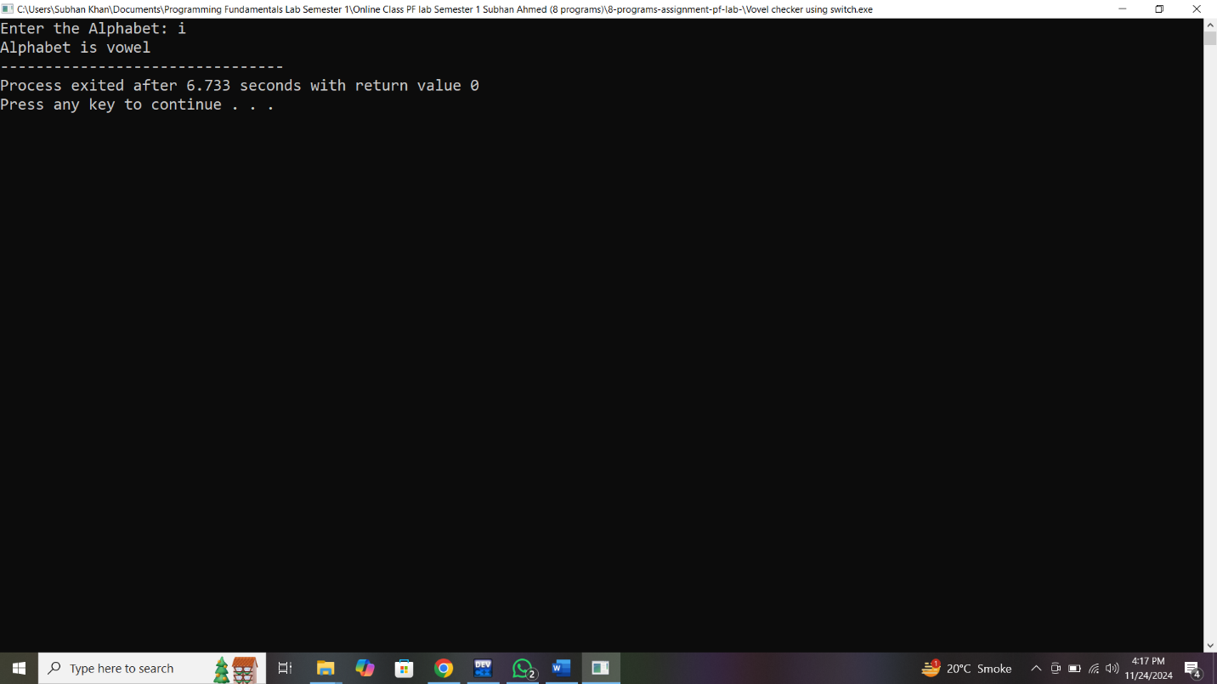

## Program 7:

#include <iostream>

using namespace std;

int main() {

int day;

cout << "Enter Number of Day: ";

cin >> day;

switch (day) {

case 1:

cout << "Monday";

break;

case 2:

cout << "Tuesday";

break;

case 3:

cout << "Wednesday";

break;

case 4:

cout << "Thursday";

break;

case 5:

cout << "Friday";

break;

case 6:

cout << "Saturday";

break;

case 7:

cout << "Sunday";

break;

}

}

## Output:

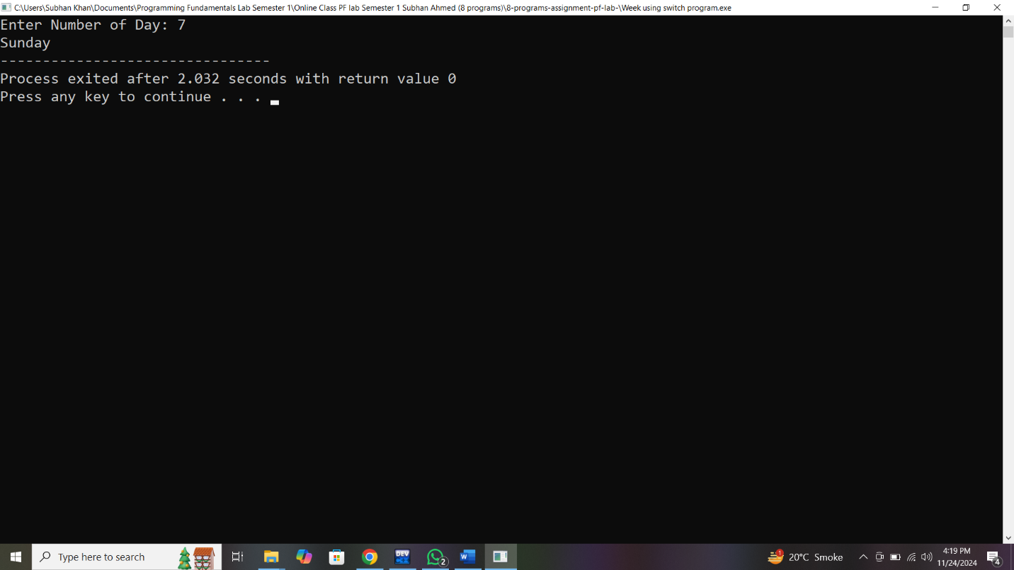

## Program 8:

#include <iostream>

using namespace std;

int main() {

for(int i=1;i<=5;i++){

cout << "Welcome to School"<<endl;

}

}

## Output:

